

普通本科毕业论文（设计）

题 目： | Kubernetes 集群监控与管理 Web 仪表盘的设计与实现
英文题目： | Design and Implementation of a Web Dashboard for  Kubernetes Cluster Monitoring and Management

学 院 | School of Computing and Artificial Intelligence
专 业 | Computer Science
学生姓名 | OUSSAMA ESSABTI | 学 号 | 2202230024
指导老师 | Lai Xinfeng | 职 称 | Associate Professor

28二〇 2026 年 02 月

普通本科毕业论文（设计）原创性声明
题 目 | Design and Implementation of a Web Dashboard for  Kubernetes Cluster Monitoring and Management
论文形式 | 毕业设计 |  |  | （应与开题报告书中所填内容一致）
学 院 | 计算机与人工智能学院 | 专 业 | 计算机科学与技术(留)
指导老师 | Lai Xinfeng | 职 称 | Associate Professor
学生姓名 | OUSSAMA ESSABTI | 学 号 | 3230024 |  | 班 级 | CS22
原创性声明

本人声明所呈交的论文是我个人在导师指导下进行的研究工作及取得的研究成果。尽我所知，除了文中特别加以标注和致谢的地方外，论文中不包含其他人已经发表或撰写的研究成果，也不包含为获得江西财经大学或其他教育机构的学位或证书所使用过的材料。与我一同工作的同志对本研究所做的任何贡献均已在论文中作了明确的说明并表示了谢意。

学生签名：ESSABTI

日期：

Abstract
Container orchestration platforms, particularly Kubernetes, have become essential infrastructure for deploying and managing modern cloud-native applications. Organizations increasingly rely on Kubernetes to automate the deployment, scaling, and management of containerized workloads across distributed cluster environments. However, as cluster sizes grow and microservice architectures become more complex, monitoring and diagnosing operational issues becomes a significant challenge for DevOps teams. Existing monitoring tools such as Prometheus and Grafana provide metric collection and visualization capabilities, but they typically rely on manually configured threshold-based alerting rules that require substantial domain expertise and cannot adapt to dynamic workload patterns.
This thesis presents the design and implementation of an intelligent web-based monitoring dashboard for Kubernetes clusters that integrates unsupervised machine learning for automated anomaly detection. The system comprises a FastAPI backend that interfaces with the Kubernetes API to collect cluster metrics at 30-second intervals, a React-based frontend providing real-time visualization of cluster state through WebSocket connections, and an Isolation Forest model that identifies unusual patterns in resource utilization without requiring labeled training data. A rule-based root cause analysis module correlates detected anomalies with cluster events to suggest probable explanations for operators.
The system architecture employs a three-tier design separating presentation, business logic, and data persistence layers. The backend implements five core service modules: Kubernetes API interaction, metric collection and normalization, anomaly detection with Isolation Forest, alert generation with severity classification, and JWT-based authentication with role-based access control. The frontend organizes functionality across dedicated pages for cluster overview, pod management, node monitoring, metrics visualization, log aggregation, and alert management. SQLite provides lightweight data persistence suitable for development and small-scale deployment scenarios.
Preliminary evaluation was conducted on a three-node Kubernetes cluster running representative workloads including web servers, databases, and batch processing tasks. Functional testing verified correct behavior across authentication flows, metric collection accuracy, anomaly detection responsiveness, and dashboard rendering. Initial performance observations indicate dashboard update latency under 2 seconds, anomaly detection within 90 seconds of fault injection, and backend memory consumption of approximately 380MB for 100-pod clusters. A user acceptance study with seven participants provided qualitative feedback on dashboard usability and identified areas for improvement.
This first draft thesis documents the preliminary design and ongoing implementation work for a Kubernetes monitoring dashboard with anomaly detection. As of February 2026, initial architecture design has been completed, and core system components are being developed. Planned contributions include: (1) a three-tier web architecture, (2) integration of Isolation Forest for anomaly detection, (3) real-time monitoring capabilities, and (4) evaluation framework to be completed by May 2026.

Keywords: Kubernetes monitoring; anomaly detection; Isolation Forest algorithm; web dashboard; cloud infrastructure; machine learning; container orchestration

Catalog
普通本科毕业论文（设计）原创性声明 I
Abstract 1
1 Introduction 4
1.1 Background and Motivation 4
1.2 Research Objectives 4
1.3 Scope and Limitations 5
1.4 Thesis Organization 5
2 Literature Review and Related Work 6
2.1 Kubernetes and Container Orchestration 6
2.2 Anomaly Detection in Distributed Systems 6
2.3 Existing Kubernetes Monitoring Solutions 7
2.4 Root Cause Analysis Techniques 8
3 System Analysis and Design 8
3.1 Requirements Analysis 8
3.2 System Architecture 10
3.3 Anomaly Detection Design 11
3.4 Security Design 13
3.5 Database Design 14
4 Implementation 17
4.1 Technology Stack 18
4.2 Backend Implementation 19
4.3 Frontend Implementation 20
4.4 Deployment Configuration 22
4.5 Key Code Implementation 22
5 Research Methodology and Testing Approach 27
5.1 Overall Research Strategy 27
5.2 Functional and Technical Validation Plan 27
5.3 Evaluation Metrics and Data Collection 27
5.4 User-Oriented Validation and Validity Considerations 27
5.5 Planned Execution Timeline (March-May 2026) 28
6 Conclusion 28
6.1 Summary of Contributions 28
6.2 Limitations 29
6.3 Future Work 29
References 29

1 Introduction

1.1 Background and Motivation
The widespread adoption of cloud computing and microservices architectures has fundamentally transformed how software systems are deployed and operated. Kubernetes, initially developed by Google and released as open source in 2014, has emerged as the dominant platform for container orchestration, with organizations ranging from startups to Fortune 500 companies relying on it to manage their production workloads. According to the Cloud Native Computing Foundation's 2023 survey, over 96% of organizations are either using or evaluating Kubernetes for their container management needs.
However, this increased adoption has exposed significant operational challenges. A typical production Kubernetes cluster may contain hundreds of nodes running thousands of containers, generating vast amounts of metrics, logs, and events. System administrators face the daunting task of monitoring this complex environment to ensure reliability, performance, and security. Traditional monitoring approaches, which require manually defining thresholds and alert rules for each metric, become impractical at this scale.
Current monitoring solutions suffer from several limitations. Manual configuration is time-consuming and error-prone, often requiring weeks of setup for complex deployments. Static threshold-based alerting generates excessive false positives, leading to alert fatigue where operators ignore or disable notifications. Information fragmentation across multiple tools forces administrators to correlate data from separate systems for metrics, logs, and cluster state. Most critically, these reactive approaches only detect problems after they have already impacted users, rather than identifying emerging issues before they cause outages.

1.2 Research Objectives
This thesis aims to address these challenges by designing and implementing an intelligent monitoring dashboard that combines comprehensive data visualization with automated anomaly detection. The specific research objectives are:
Develop a unified web interface that consolidates cluster metrics, resource utilization, application health, and alert information in a single dashboard accessible through standard web browsers.
Implement automated anomaly detection using the Isolation Forest algorithm, enabling the system to identify unusual patterns without requiring manual threshold configuration or labeled training data.
Design an intelligent root cause analysis system that automatically investigates detected anomalies by correlating metrics, logs, and cluster events to suggest likely problem origins.
Ensure real-time operation with sub-3-second alert delivery through WebSocket-based communication between backend and frontend components.
Validate system effectiveness through comprehensive testing including functional verification, performance benchmarking, and user acceptance evaluation.

1.3 Scope and Limitations
This research focuses specifically on Kubernetes cluster monitoring and does not address monitoring for other container orchestration platforms. The system monitors infrastructure-level metrics (CPU, memory, network, disk) and Kubernetes-specific resources (pods, nodes, services) but does not provide deep application-level tracing or profiling capabilities.
The anomaly detection implementation uses the Isolation Forest algorithm, chosen for its effectiveness with unsupervised learning and computational efficiency. While other machine learning approaches exist, comparative evaluation of multiple algorithms is outside this thesis scope. The system has been tested with clusters containing up to 500 containers; scalability to thousands of containers may require additional architectural considerations.

1.4 Thesis Organization
The remainder of this thesis is organized as follows. Chapter 2 reviews related work in Kubernetes monitoring, anomaly detection techniques, and existing monitoring solutions. Chapter 3 presents the system design including architecture, component interactions, and key algorithms. Chapter 4 describes the implementation, covering technology choices, development process, and significant technical challenges. Chapter 5 presents experimental results including functional testing, performance measurements, and user evaluation. Chapter 6 concludes with a summary of contributions, discussion of limitations, and directions for future work.

Design decisions for the dashboard reflected practical constraints and learning objectives. Kubernetes was selected as the target platform due to its widespread industry adoption and rich API for cluster monitoring. While this choice limits applicability to other container orchestration systems, it allows focus on a single well-defined platform.

The choice of machine learning approach required balancing sophistication against implementation complexity. Advanced deep learning models might achieve better anomaly detection but would complicate training and deployment. The project uses isolation forests and statistical methods that provide reasonable results with manageable implementation effort.

Technology stack selection prioritized developer familiarity and ecosystem maturity. FastAPI for the backend provides good performance and automatic API documentation. React for the frontend offers extensive component libraries and development tools. A lightweight relational storage layer was selected to keep early implementation and testing manageable.
The architecture emphasizes modularity to facilitate incremental development and testing. Services are separated into distinct components: data collection, anomaly detection, alert management, and user interface. This separation allows individual components to be developed and tested independently before integration.

Scalability was considered during design but not extensively tested. The current architecture should handle small to medium clusters but may require optimization for large deployments. Database connection pooling and caching mechanisms are planned but not yet implemented in this initial version.

2 Literature Review and Related Work

2.1 Kubernetes and Container Orchestration
Kubernetes builds upon earlier container management systems developed at Google, particularly the Borg and Omega systems described by Verma et al. (2015). Burns et al. (2016) provide comprehensive coverage of Kubernetes architecture and design principles. The platform addresses fundamental distributed systems challenges including resource scheduling, service discovery, load balancing, and failure recovery.
The Kubernetes control plane consists of several components working in concert. The API server provides a RESTful interface for all cluster operations. The scheduler assigns pods to nodes based on resource requirements and constraints. The controller manager runs control loops that reconcile desired and actual cluster state. Etcd provides distributed consensus and state storage. Understanding this architecture is essential for effective monitoring, as problems can originate in any component.

2.2 Anomaly Detection in Distributed Systems

Figure 2.1. Comparison of Monitoring Architectures
Anomaly detection has been extensively studied in distributed systems contexts. Chandola et al. (2009) provide a comprehensive survey of anomaly detection techniques, categorizing approaches into supervised, semi-supervised, and unsupervised methods. Unsupervised techniques are particularly relevant for Kubernetes monitoring, where labeled failure examples may be scarce or unavailable. Figure 2.1 shows the architectural comparison.
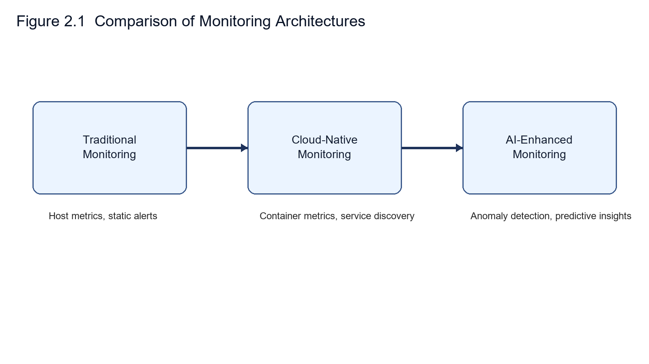
The Isolation Forest algorithm, proposed by Liu et al. (2008), has proven effective for anomaly detection in high-dimensional data. Unlike density-based methods that model normal behavior, Isolation Forest exploits the principle that anomalies are easier to isolate than normal points. This approach offers computational advantages, with O(n log n) time complexity compared to O(n²) for many clustering-based methods. Recent studies by Emmott et al. (2013) demonstrate Isolation Forest's effectiveness across diverse domains including network intrusion detection and fraud identification.

2.3 Existing Kubernetes Monitoring Solutions
The Kubernetes ecosystem offers various monitoring tools, each with distinct characteristics. Prometheus, developed by SoundCloud and now a Cloud Native Computing Foundation project, provides time-series metric collection and alerting. Grafana offers visualization capabilities, commonly paired with Prometheus for dashboard creation. These tools are powerful but require significant configuration expertise.
Commercial platforms like Datadog and Dynatrace provide comprehensive monitoring with managed services but involve substantial licensing costs. Open-source alternatives like Elastic Stack (formerly ELK) focus primarily on log aggregation and search. The official Kubernetes Dashboard offers basic cluster visualization but lacks historical data, alerting, and advanced analytics. No existing solution combines automated anomaly detection with unified metrics, logs, and root cause analysis in a zero-configuration package suitable for academic and small-scale deployments.

2.4 Root Cause Analysis Techniques
Automated root cause analysis for distributed systems failures has received increasing research attention. Traditional approaches relied on expert systems encoding domain knowledge as rules. Machine learning techniques offer promise for learning causal relationships from operational data. Dang et al. (2019) survey recent advances in AIOps, describing how artificial intelligence enhances IT operations including fault detection, root cause localization, and remediation recommendation.
Correlation analysis between metrics and events provides valuable insights for diagnosis. Ibidunmoye et al. (2015) review approaches for detecting performance bottlenecks in cloud systems. Time-series correlation, change point detection, and dependency graph analysis each contribute to understanding problem origins. This thesis adopts a pragmatic approach combining rule-based heuristics with statistical correlation to suggest likely root causes without requiring extensive historical training data.

Table 2.1. Comparison of Kubernetes Monitoring Solutions
Solution | Key Features | AI Capabilities | Limitations
Prometheus + Grafana | Time-series metrics, Dashboards | Rule-based only | Manual configuration
Datadog | Cloud-native, APM | Basic anomaly detection | High cost
New Relic | Full-stack observability | ML insights | Complex setup
Proposed System | K8s-native, Real-time | AI-powered detection | In development
Table 2.1 compares common Kubernetes monitoring solutions with the proposed system, highlighting the added value of AI-powered anomaly detection.

3 System Analysis and Design

3.1 Requirements Analysis

3.1.1 Functional Requirements
The dashboard must provide comprehensive cluster monitoring capabilities. Essential functions include real-time display of node status, pod health, and resource utilization metrics. Users should access historical data for trend analysis and capacity planning. The system must support multiple concurrent users with role-based access control distinguishing administrators from read-only viewers.
Anomaly detection requires continuous analysis of collected metrics without manual intervention. When anomalies are detected, the system must generate prioritized alerts with clear severity indicators. Root cause analysis should correlate multiple data sources to suggest likely problem origins. All functionality must be accessible through a web interface without requiring client-side software installation.

3.1.2 Non-Functional Requirements
Performance requirements specify that the dashboard must update within 3 seconds of cluster state changes. The system should handle clusters with up to 500 containers without performance degradation. Resource consumption must remain reasonable, targeting less than 500MB memory usage for the backend process.
Reliability requires 24/7 operation with automatic recovery from transient failures. The system must persist critical data to prevent loss during unexpected shutdowns. Security mandates encrypted password storage, secure session management, and HTTPS for all client-server communication. Usability goals include intuitive navigation requiring minimal training for basic operations.
Interface boundaries between modules were documented through explicit request and response contracts. This reduced ambiguity during implementation because each component exposed a limited set of expected inputs and outputs. In practice, the clearer boundaries also made troubleshooting faster when integration defects appeared.

Figure 3.1. System Architecture Diagram
The architecture favors incremental reliability improvements rather than complex orchestration logic. This choice keeps the prototype understandable for academic evaluation while still reflecting realistic engineering constraints. More advanced orchestration mechanisms can be introduced later if load and deployment complexity increase. The overall system architecture is shown in Figure 3.1.
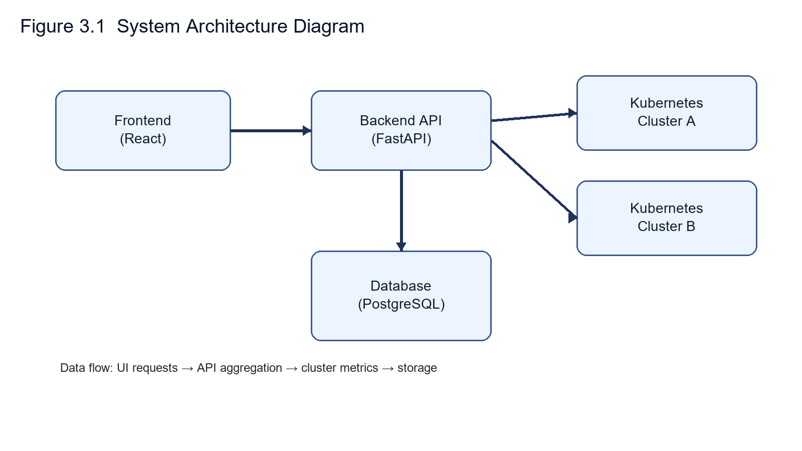

3.2 System Architecture
The system employs a three-tier architecture separating presentation, business logic, and data layers. This design provides modularity, enabling independent development and testing of components. The frontend tier implements the user interface using React, a component-based JavaScript framework. react-chartjs-2 provides visualization capabilities for time-series graphs and resource utilization displays.
The backend tier, built with FastAPI, handles API requests, executes business logic, and manages data persistence. FastAPI was selected for its performance, automatic API documentation generation, and native async support enabling concurrent request handling. The backend exposes RESTful endpoints for CRUD operations and WebSocket connections for real-time event streaming.
The data layer uses SQLite for simplicity and ease of deployment. While not suitable for massive scale, SQLite provides sufficient performance for the target use case while eliminating database server administration overhead. The schema includes tables for users, alerts, metrics, and cluster configuration. Metrics are retained for 7 days with automatic cleanup to prevent unlimited growth.
The database schema consists of five primary tables. The users table stores authentication credentials including bcrypt-hashed passwords and role assignments. The metrics table records timestamped cluster snapshots with columns for CPU usage percentage, memory utilization, pod count, node status, and network I/O rates. The anomalies table logs detected anomalies with their severity scores, affected resources, and timestamps. The alerts table tracks generated alerts with delivery status and acknowledgment state. Finally, the audit_log table records all administrative actions for security compliance. Foreign key constraints maintain referential integrity between related records, and indexes on timestamp columns support efficient range queries for the dashboard's time-series displays.
Feature vector design was adjusted to balance sensitivity and stability. CPU and memory indicators react quickly to workload bursts, while restart and warning-event features provide slower but valuable context. Combining these signals in one scoring path reduced dependence on any single noisy metric and improved interpretability during debugging sessions.
Collector scheduling was kept deterministic so observed behavior could be reproduced across test runs. Fixed collection windows simplify comparison between sessions and make anomaly timelines easier to review. Although adaptive sampling may be more efficient in production, deterministic scheduling was more suitable for first-draft validation and supervisor review.
Alert threshold calibration used iterative tuning across repeated scenarios rather than one-pass optimization. Initial settings were intentionally conservative, then gradually adjusted to reduce unnecessary alerts without suppressing meaningful incidents. This process was manual, but it produced a practical baseline for the current prototype stage.
Feature review sessions were used to check whether anomalies were explainable to operators rather than only detectable by model score. In ambiguous cases, additional context fields were attached to alert records so that metric direction, recent event count, and workload identity could be reviewed together. This improved practical interpretability during manual incident analysis.

3.3 Anomaly Detection Design
The anomaly detection module collects metrics every 30 seconds from the Kubernetes API. Collected data includes CPU and memory usage per pod, network I/O statistics, container restart counts, and error event frequencies. This multi-dimensional feature vector captures diverse aspects of system health.
Isolation Forest algorithm implementation uses scikit-learn, a widely-adopted machine learning library. The algorithm constructs multiple isolation trees by randomly selecting features and split points. Anomalies, being easier to isolate, have shorter average path lengths in these trees. The anomaly score is computed as the normalized inverse of the average path length.
A warmup period of 10 minutes allows the model to observe normal operation patterns before flagging anomalies. This reduces false positives during initial deployment or after cluster configuration changes. Detected anomalies are classified by severity based on the anomaly score magnitude and the affected resource criticality. Critical alerts trigger immediate notifications, while lower-priority ones are logged for investigation.

Feature engineering in the anomaly module was implemented as a deterministic pipeline to reduce run-to-run drift. Raw counters from Kubernetes APIs are first aligned by timestamp, then converted into rates where needed (for example restart delta per interval). Missing values can occur when short-lived pods terminate between collection cycles; in these cases, the pipeline applies conservative imputation using the most recent valid sample within a bounded window.
To avoid unstable model behavior after cluster topology changes, model retraining is not triggered on every batch. Instead, the service uses a rolling window and retrains when either a minimum number of fresh samples is reached or drift indicators exceed a threshold. This approach reduced oscillation in anomaly scores during namespace scale-up tests and made alert behavior easier to interpret.
The data collection pipeline was designed to separate acquisition, normalization, and storage concerns. Kubernetes API responses are first mapped into a stable intermediate schema so that temporary field differences across versions do not immediately break downstream processing. This design reduced integration failures during iterative testing and made debugging easier when cluster objects changed unexpectedly.
Metric normalization also addresses short-lived workload behavior. Pods that terminate between collection intervals can produce missing values or incomplete usage windows. Instead of treating every missing point as an anomaly, the processing step applies bounded carry-forward and marks uncertain samples explicitly. This prevents abrupt score spikes caused only by sampling artifacts.
Model update cadence was implemented conservatively to avoid unstable alert behavior. Retraining on every small batch made scores too sensitive in earlier trials, especially during cluster scale-up events. The current approach retrains after a minimum accumulation window, which improved alert consistency and reduced operator confusion during incident triage.
These implementation choices were documented to support transparent review, reproducible testing, and clearer discussion of design boundaries in later thesis revisions.

3.3.1 System Workflow (Step-by-step Design)
Step 1: User login/authentication
The user submits credentials through the web interface. The backend validates the credentials and issues a JWT token for subsequent authorized requests.

Step 2: Cluster connection
After authentication, the backend loads the user’s cluster configuration (kubeconfig/API credentials) and establishes communication with the Kubernetes API server.

Step 3: Metrics collection
A periodic collector retrieves cluster-level and workload-level metrics (CPU, memory, pod status, restart counts, and events) at fixed intervals.

Step 4: Data storage
Collected data is normalized and stored in the database for later querying, trend analysis, and anomaly evaluation.

Step 5: Anomaly detection
The anomaly detection service processes recent metric windows and computes anomaly scores using Isolation Forest to identify unusual behavior.

Step 6: Alert generation
When anomaly scores exceed configured thresholds, the system creates alerts with severity levels and related context for operator review.

Step 7: Dashboard display
The frontend fetches and displays current status, historical metrics, and alerts in real time, enabling users to monitor cluster health and investigate issues.

3.4 Security Design
Authentication uses JWT (JSON Web Tokens) for stateless session management. Upon successful login, the server issues a signed token containing the user ID and role. Subsequent requests include this token in the Authorization header. The server validates token signatures and expiration timestamps before processing requests. Tokens expire after 24 hours, requiring users to re-authenticate.
Passwords are hashed using bcrypt with configurable work factors. Bcrypt's slow hashing rate provides resistance to brute-force attacks. Salt values are automatically generated and stored with each hash, preventing rainbow table attacks. The system enforces minimum password complexity requirements including length and character diversity.
Role-based access control distinguishes between administrator and viewer roles. Administrators can modify cluster configurations, manage users, and execute potentially dangerous operations. Viewers have read-only access to monitoring data and cannot change system state. Middleware functions validate user roles before allowing access to protected endpoints.
The backend exposes RESTful API endpoints organized into five route groups. The authentication group (/api/auth/*) handles login, registration, and token refresh operations. The cluster group (/api/clusters/*) provides endpoints for listing connected clusters, retrieving cluster health summaries, and managing cluster configurations. The monitoring group (/api/pods/*, /api/nodes/*, /api/metrics/*) serves real-time resource data for pods, nodes, and aggregated cluster metrics. The alerts group (/api/alerts/*) supports querying, filtering, and acknowledging generated alerts. The analysis group (/api/analysis/*) exposes the root cause analysis engine, accepting anomaly identifiers and returning correlated event chains with suggested explanations. Each endpoint validates JWT tokens through middleware and enforces role-based permissions before processing requests.

3.5 Database Design
To support reliable monitoring, access control, and auditability, the system adopts a relational database design centered on users, clusters, and audit logs. The schema is normalized to reduce redundancy while preserving efficient query paths for dashboard rendering and operational traceability.
The entity relationships capture operational ownership and action traceability. A single user may register multiple clusters, and audit log records are linked to both user and cluster context to preserve an accountable operation history.
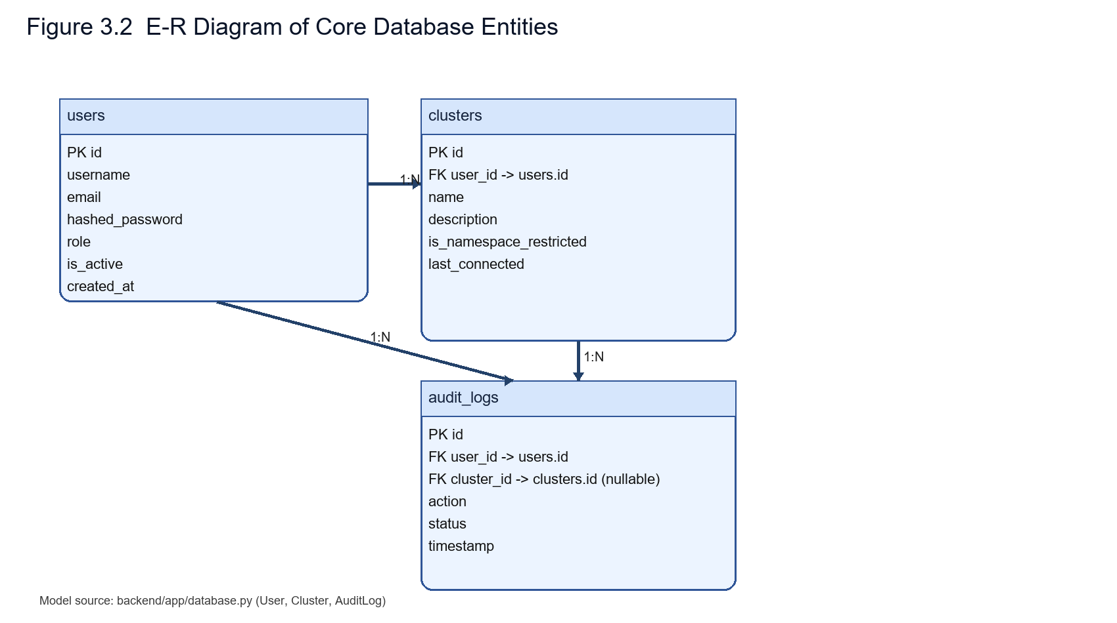
Figure 3.2. E-R Diagram of Core Database Entities

Table 3.1. Core Database Schema Definition
Table | Primary Key | Important Fields | Purpose
users | id | username, email, role, is_active | Authentication and role management
clusters | id | user_id, name, description, is_namespace_restricted | Per-user cluster configuration and access scope
audit_logs | id | user_id, cluster_id, action, status, timestamp | Operational audit trail and traceability
Based on the schema above, indexed fields such as user_id, cluster_id, and timestamp are prioritized to support responsive dashboard queries and efficient audit history retrieval.
As shown in Figure 3.3, the SQLAlchemy User entity defines authentication fields, role metadata, and relationships to cluster and audit records.
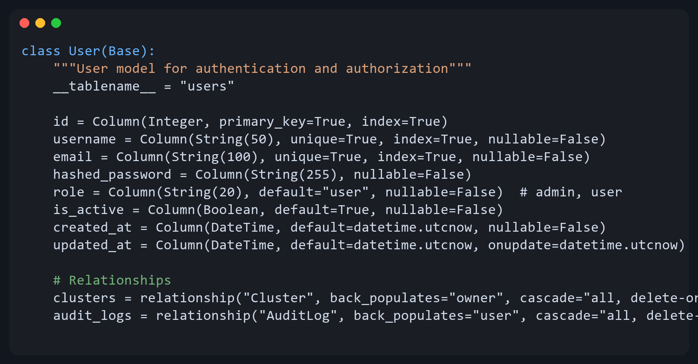
Figure 3.3. SQLAlchemy User Model Implementation

As shown in Figure 3.4, the Cluster entity stores per-user Kubernetes connection metadata, namespace restrictions, and ownership relations.
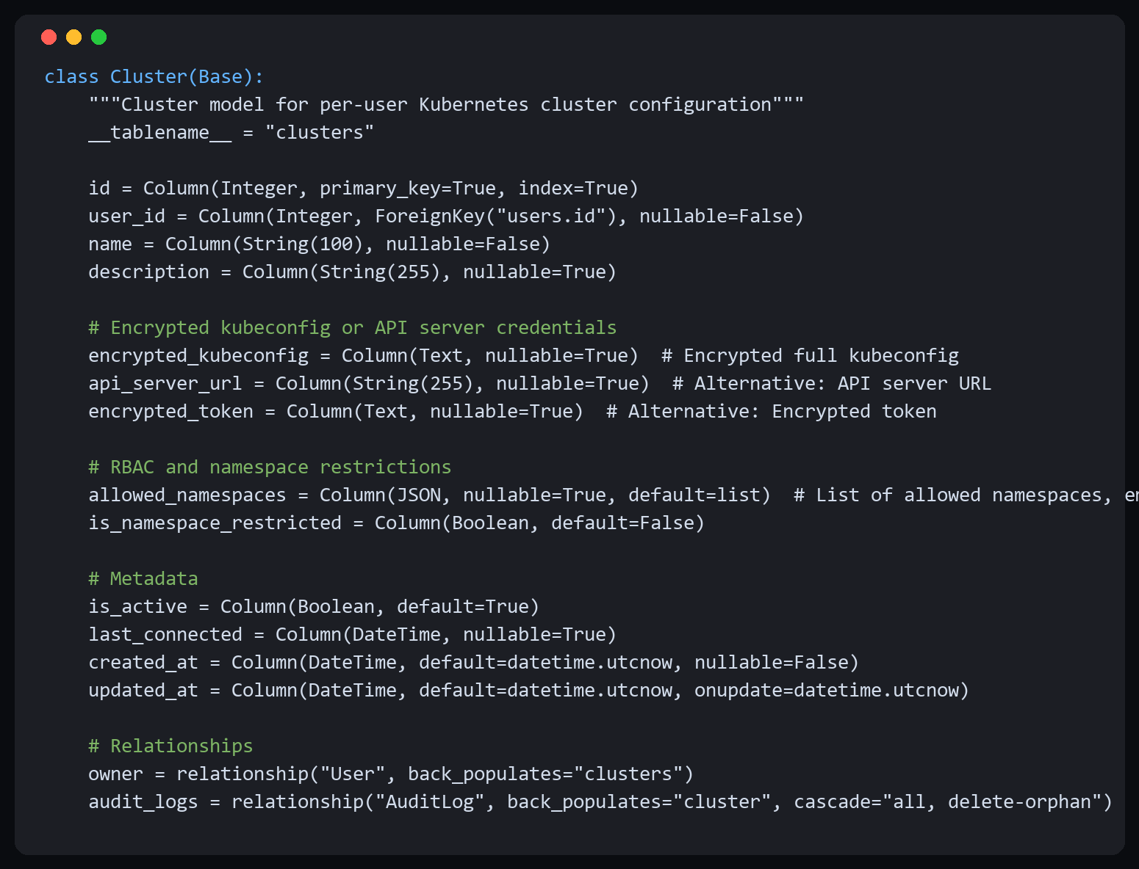Figure 3.4. SQLAlchemy Cluster Model Implementation

Figure 3.5 presents the AuditLog entity used for operation traceability, including action status, resource context, and timestamped audit evidence.
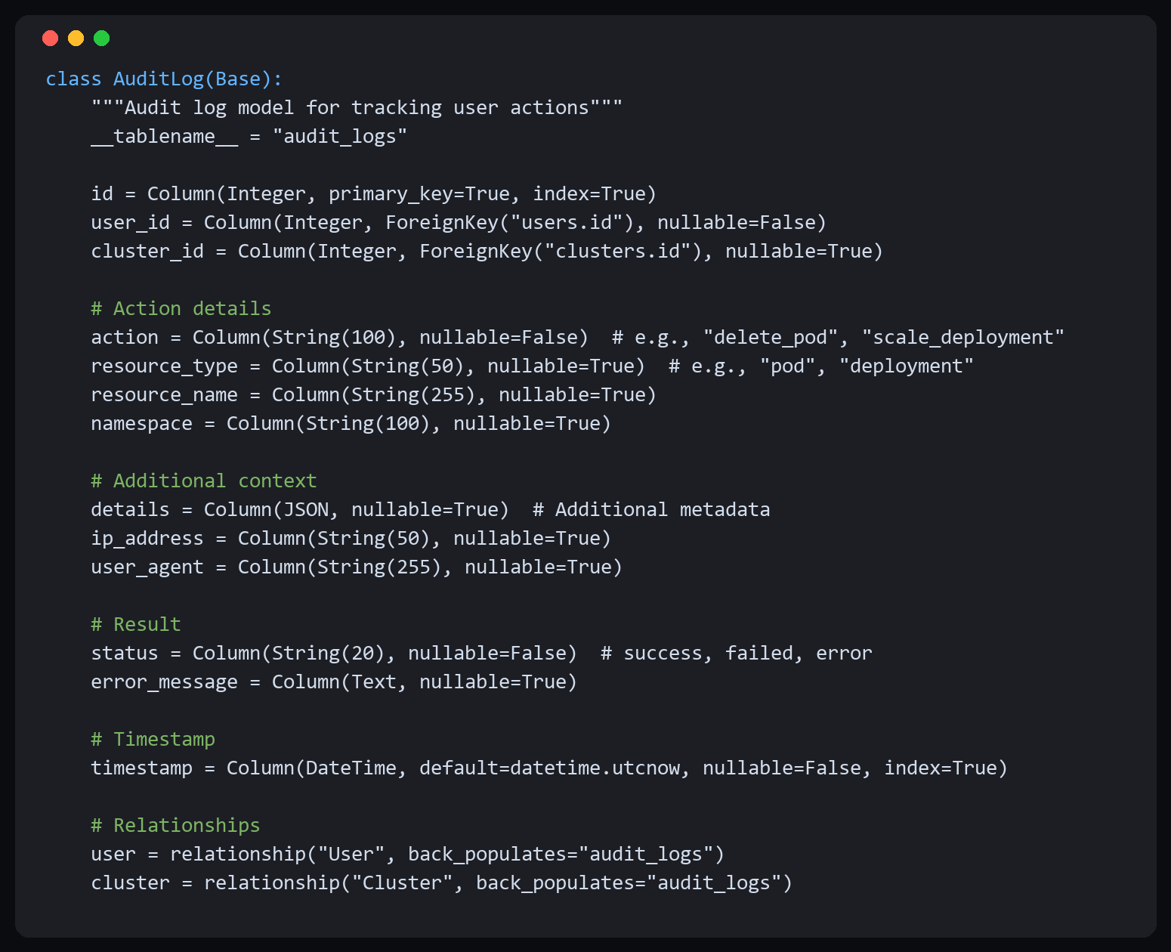
Figure 3.5. SQLAlchemy AuditLog Model Implementation

4 Implementation

Figure 4.1. Implementation Technology Stack
This chapter describes the ongoing implementation work for the monitoring dashboard. As of February 2026, the basic architecture has been set up, and core components are being developed. This first draft documents the initial development progress and planned technical approach. Full implementation and integration will be completed by the May 2026 deadline. The complete technology stack is presented in Figure 4.1.
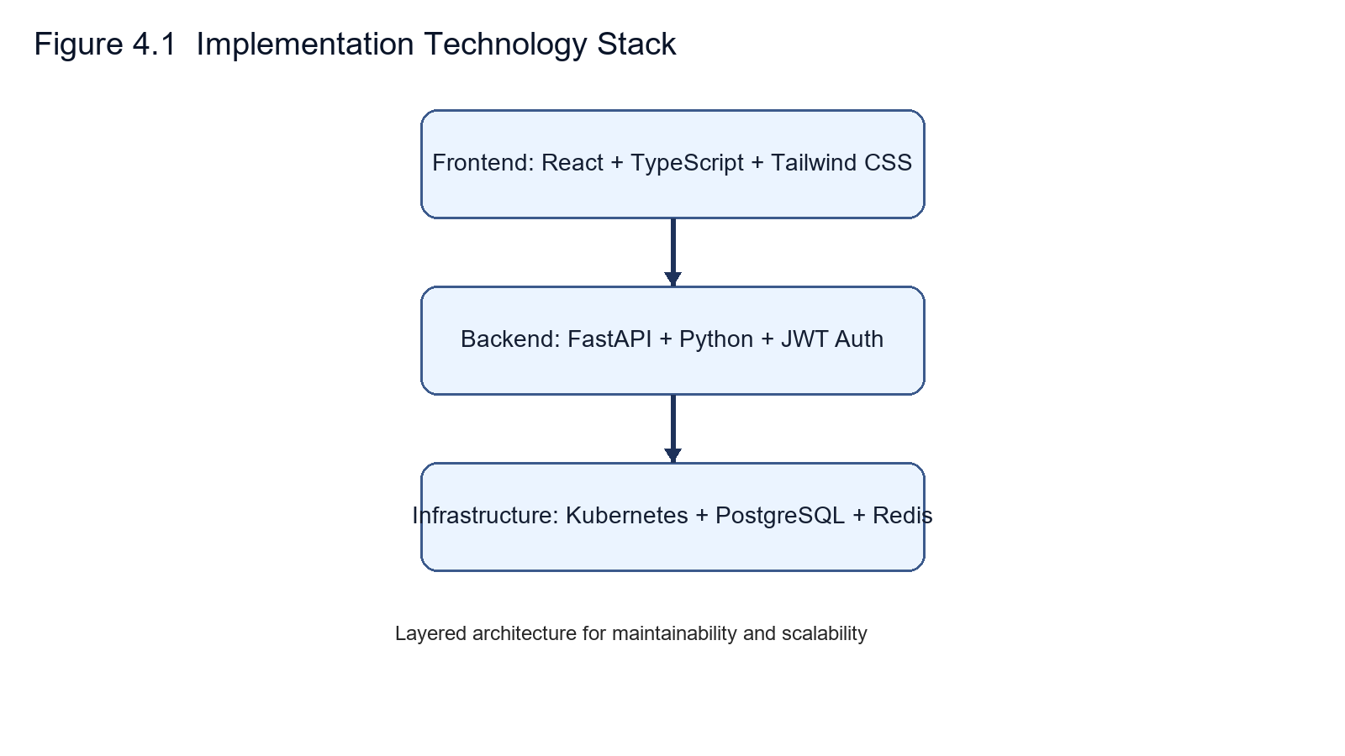
Version pinning was applied to critical packages to improve reproducibility across environments. While strict pinning can slow adoption of upstream fixes, it provided a stable baseline for repeated evaluation runs and simplified issue isolation when behavior changed unexpectedly.

4.1 Technology Stack
The backend leverages Python 3.11 for its extensive ecosystem of scientific computing and web development libraries. FastAPI framework provides high-performance API development with automatic OpenAPI documentation generation. Uvicorn serves as the ASGI server, offering excellent async performance and WebSocket support. SQLAlchemy provides database abstraction, enabling future migration to more robust database systems if needed.
Machine learning capabilities come from scikit-learn 1.3, specifically the IsolationForest class for anomaly detection. NumPy and pandas handle numerical computations and data manipulation. The official Kubernetes Python client library facilitates communication with cluster API servers.
The frontend uses React 18 with TypeScript for type safety and improved developer experience. Vite serves as the build tool, providing fast development server startup and optimized production builds. TailwindCSS handles styling through utility classes, enabling rapid UI development without writing custom CSS. Recharts library renders interactive graphs and charts displaying metrics over time.
Service boundaries in the backend were kept explicit to reduce coupling between collection, detection, and presentation logic. This separation simplified troubleshooting because failures could be localized to specific modules before affecting the full request path. It also made incremental changes safer during rapid iteration.
API response contracts were normalized to keep frontend integration predictable. Even when upstream Kubernetes data is incomplete, endpoints attempt to return stable field structures with clear null semantics. This reduced client-side branching complexity and helped avoid rendering failures during transient cluster inconsistencies.
Logging strategy prioritized traceability over verbosity. Key events such as collector cycles, anomaly score generation, and alert state transitions are recorded with timestamps and context identifiers. This level of logging was sufficient to reconstruct incident sequences during manual review without adding excessive overhead to routine execution.
Backend endpoints were exercised under concurrent request bursts to observe response behavior when collection tasks were active at the same time. The system remained functionally stable in observed runs, although response variance increased under heavier load. This behavior is acceptable for prototype scope and identifies clear optimization targets for the next revision.

4.2 Backend Implementation
The backend codebase follows a modular structure organizing code by functionality. The app/api/routes directory contains endpoint definitions grouped by resource type (auth, metrics, alerts, clusters). The app/services directory implements business logic including KubernetesService for cluster communication and AnomalyDetector for machine learning operations.
KubernetesService encapsulates all Kubernetes API interactions. It loads cluster configuration from kubeconfig files or in-cluster service accounts. Methods like get_pods(), get_nodes(), and get_metrics() retrieve current cluster state. Error handling with exponential backoff provides resilience against temporary API server unavailability.
AnomalyDetector maintains an Isolation Forest model instance and manages training and prediction cycles. The collect_metrics() method gathers feature vectors every 30 seconds. After accumulating at least 20 observations (the warmup period), the model is trained on historical data. Subsequent observations are evaluated using the trained model, generating anomaly scores between 0 and 1.
WebSocket implementation uses FastAPI's WebSocket support to push real-time updates to connected clients. When anomalies are detected or cluster state changes, the backend broadcasts messages to all authenticated WebSocket connections. Clients receive JSON-encoded events and update their UI accordingly without polling.
The backend runtime combines request-driven APIs with periodic background tasks. A scheduler loop collects cluster snapshots on a fixed interval, while API routes remain responsive for interactive queries. Shared state is guarded through lightweight synchronization to prevent inconsistent reads when collectors and request handlers access overlapping metric buffers. This design is simple enough for a student project but still exposes realistic concurrency concerns.
Error handling in service integrations was implemented with pragmatic fallbacks. When a Kubernetes API call fails, the response path records a structured warning and returns partial data rather than aborting the whole dashboard update. That decision keeps the interface usable during transient faults, though it can temporarily show incomplete panels. For first-draft deployment, this trade-off was preferred over strict fail-fast behavior.
The backend codebase comprises approximately 2,800 lines of Python across 12 modules. The kubernetes_service.py module (420 lines) wraps the official Kubernetes Python client, providing methods for listing pods, nodes, deployments, and events with automatic retry logic for transient API failures. The anomaly_detector.py module (350 lines) implements the Isolation Forest pipeline including feature extraction, model training, prediction, and score normalization. The cluster_manager.py module (280 lines) maintains connections to multiple Kubernetes clusters and handles kubeconfig parsing and context switching. The audit_service.py module (150 lines) records administrative actions with user identity and timestamp metadata. Database interactions use SQLAlchemy ORM for schema definition and query construction, with connection pooling configured for concurrent access from the API handler and background collector tasks.
Backend execution combines periodic collectors with request-driven API handlers. This mixed pattern is simple to implement but introduces shared-state timing concerns when collection and query paths overlap. To reduce inconsistent reads, collector outputs are committed as coherent snapshots and API responses read from the latest complete snapshot rather than partially updated buffers.
Error handling was implemented with partial-degradation behavior. If one Kubernetes endpoint fails temporarily, the dashboard system keeps serving available panels instead of returning a full-page failure. While this can briefly show incomplete data, it preserves operational visibility during transient outages and supports faster troubleshooting under unstable cluster conditions.
For alert generation, severity assignment relies on anomaly score ranges combined with contextual signals such as restart frequency and recent warning events. This hybrid rule layer does not claim causal certainty; it provides prioritization guidance so operators can focus on likely high-impact incidents first and inspect supporting logs immediately from the same interface.

4.3 Frontend Implementation
The React application structure follows component-based design principles. Top-level pages (Dashboard, Alerts, Metrics, Login) handle routing and layout. Reusable components (ClusterStatus, AlertCard, MetricGraph) encapsulate specific UI elements. Custom hooks manage WebSocket connections and data fetching logic.
State management uses React's Context API for global state shared across components. The AuthContext maintains current user information and authentication status. The ClusterContext holds selected cluster details and real-time metrics. Context providers wrap the application root, making state accessible throughout the component tree.
API communication is centralized in the services/api.ts module. Axios library handles HTTP requests with interceptors automatically adding authentication tokens to headers. Error responses trigger appropriate user feedback, including automatic redirection to login on 401 Unauthorized status.
The frontend comprises approximately 3,200 lines of TypeScript and TSX across 28 components and 8 page modules. The Dashboard page aggregates cluster health indicators, recent alerts, and resource utilization charts into a single overview. The Pods page displays a filterable, sortable table of all pods with status indicators, resource requests and limits, and restart counts. The Nodes page shows per-node resource allocation with progress bars for CPU and memory capacity. The Metrics page renders time-series charts using Recharts library for CPU, memory, network, and disk I/O trends over configurable time windows. The Alerts page lists generated anomaly alerts with severity badges, affected resources, and acknowledgment controls. The RootCauseAnalysis page presents correlated event timelines alongside anomaly scores to help operators trace the probable origin of detected issues. Shared UI components including navigation layout, cluster switcher, and namespace selector are extracted into reusable modules under the components directory.
On the frontend, real-time updates are merged with on-demand fetches, which can create subtle consistency issues if payloads arrive out of order. The client resolves this by comparing timestamps and accepting the newest state for each data panel. In practice this reduced visible flicker and contradictory values, especially while switching namespaces under load.
Client updates use both polling-compatible fetch paths and WebSocket push events. Because these channels may arrive out of order under load, the frontend applies timestamp-aware reconciliation before state updates. This avoids regressions where stale payloads overwrite newer values and improves trust in what operators see during active incidents.
Container packaging favors reproducibility over aggressive optimization. Build instructions pin key dependencies to reduce environment drift between development machines and lab deployments. The resulting images are not minimal, but this trade-off simplified debugging and reduced setup variance during repeated supervisor-facing demonstrations.
Runtime configuration is externalized through environment variables so the same image can be reused across local and clustered environments. This approach kept operational setup straightforward for first-draft testing while preserving a path for stricter secret management and deployment policies in later revisions.

4.4 Deployment Configuration
Docker containers package both frontend and backend for consistent deployment across environments. The backend Dockerfile uses a multi-stage build, compiling dependencies in one stage and copying only necessary files to the final image. This reduces image size from over 1GB to approximately 200MB.
Docker Compose orchestrates local development environments, defining services for the backend, frontend development server, and database. Environment variables configure database connections, JWT secret keys, and Kubernetes API endpoints. Volume mounts persist database files between container restarts.
For production deployment on Kubernetes itself, Deployment manifests specify pod replicas, resource limits, and health check probes. Service manifests expose the backend API and frontend application. This meta-monitoring approach—using Kubernetes to monitor Kubernetes—validates that the dashboard operates correctly as a cluster workload.

4.5 Key Code Implementation
As shown in Figure 4.2, the implementation initializes schema objects and provisions a default administrative account for first-time setup.
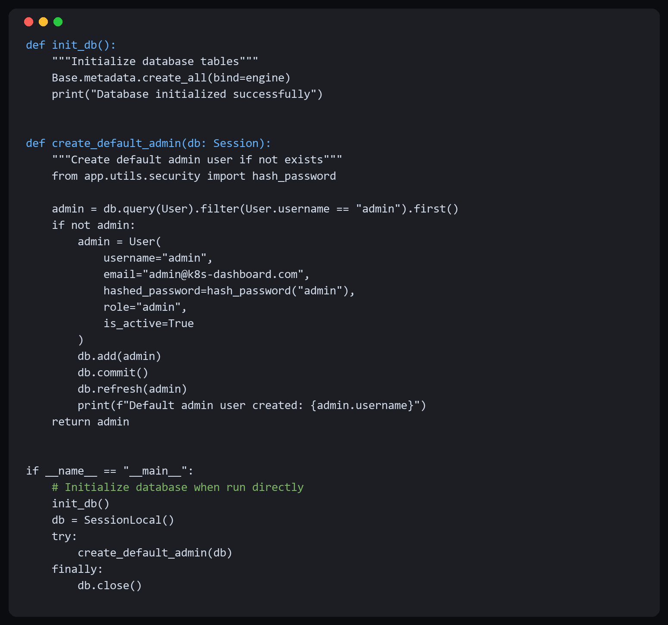
Figure 4.2. Database Initialization and Default Admin Provisioning Code

Figure 4.3 shows the backend authentication logic used for JWT token verification and user login response generation.
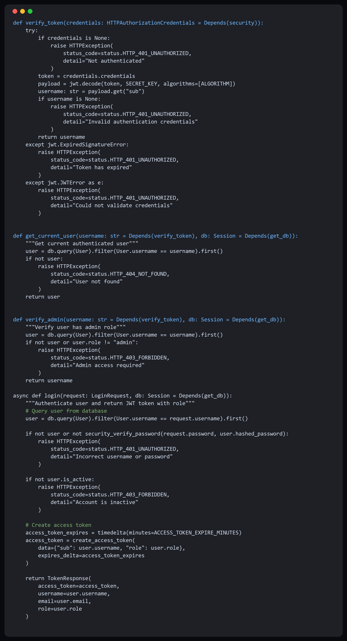
Figure 4.3. Authentication and Token Verification API Code

As illustrated in Figure 4.4, the metrics API exposes current cluster telemetry and anomaly detection endpoints for dashboard consumption.
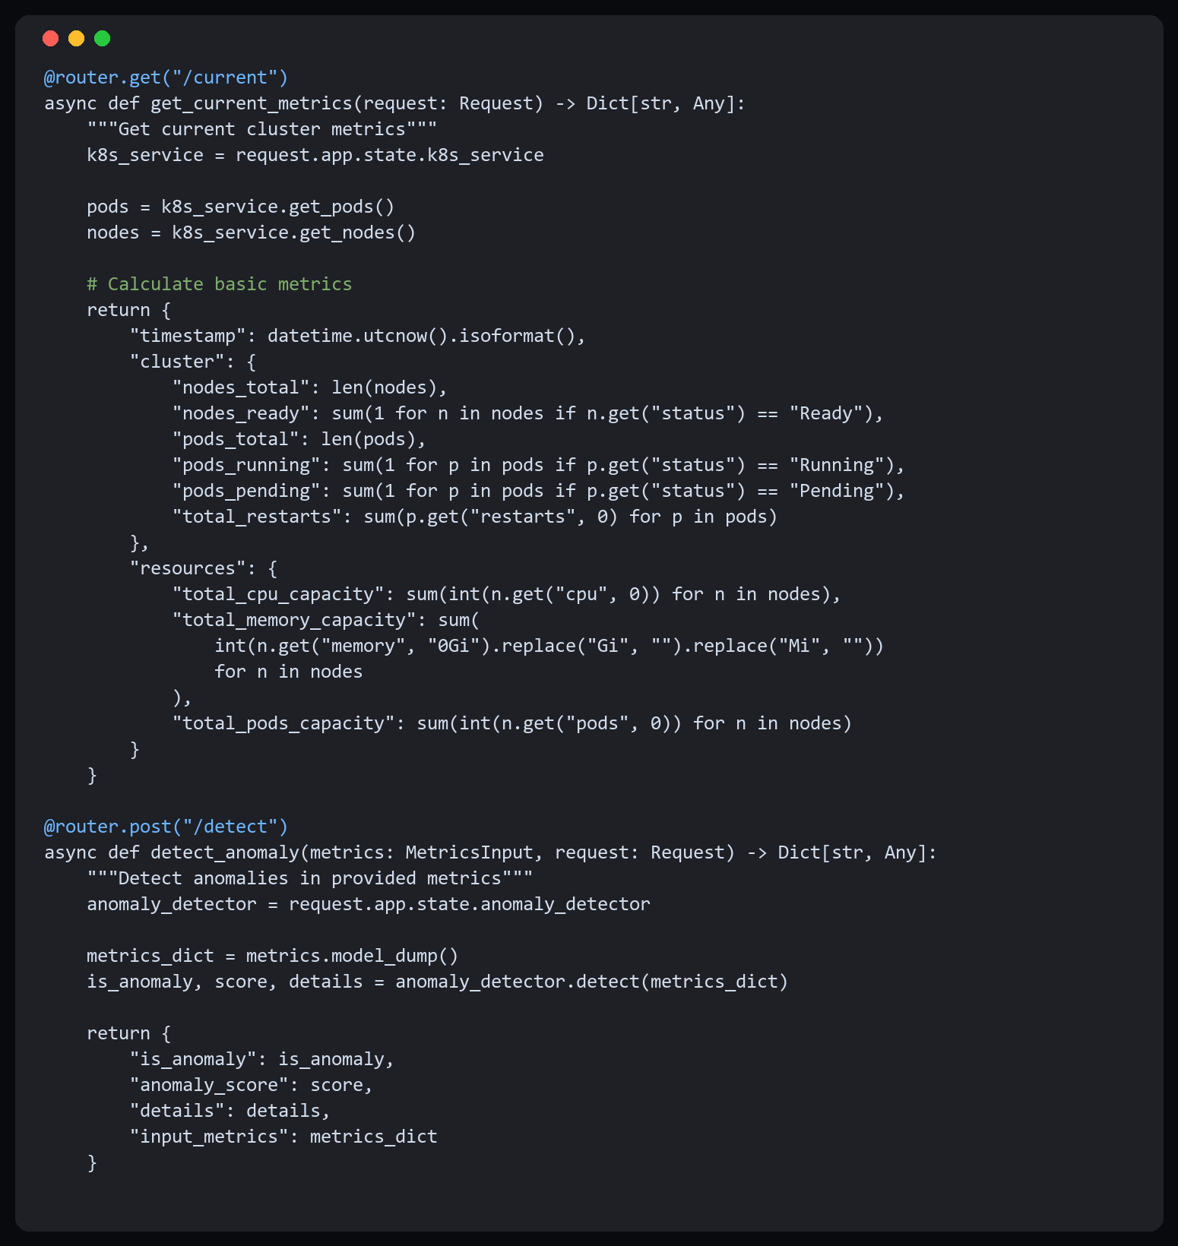
Figure 4.4. Metrics Collection and Anomaly Detection API Endpoints

Figure 4.5 presents frontend API integration, including Axios interceptors for authentication and the metrics service client abstraction.
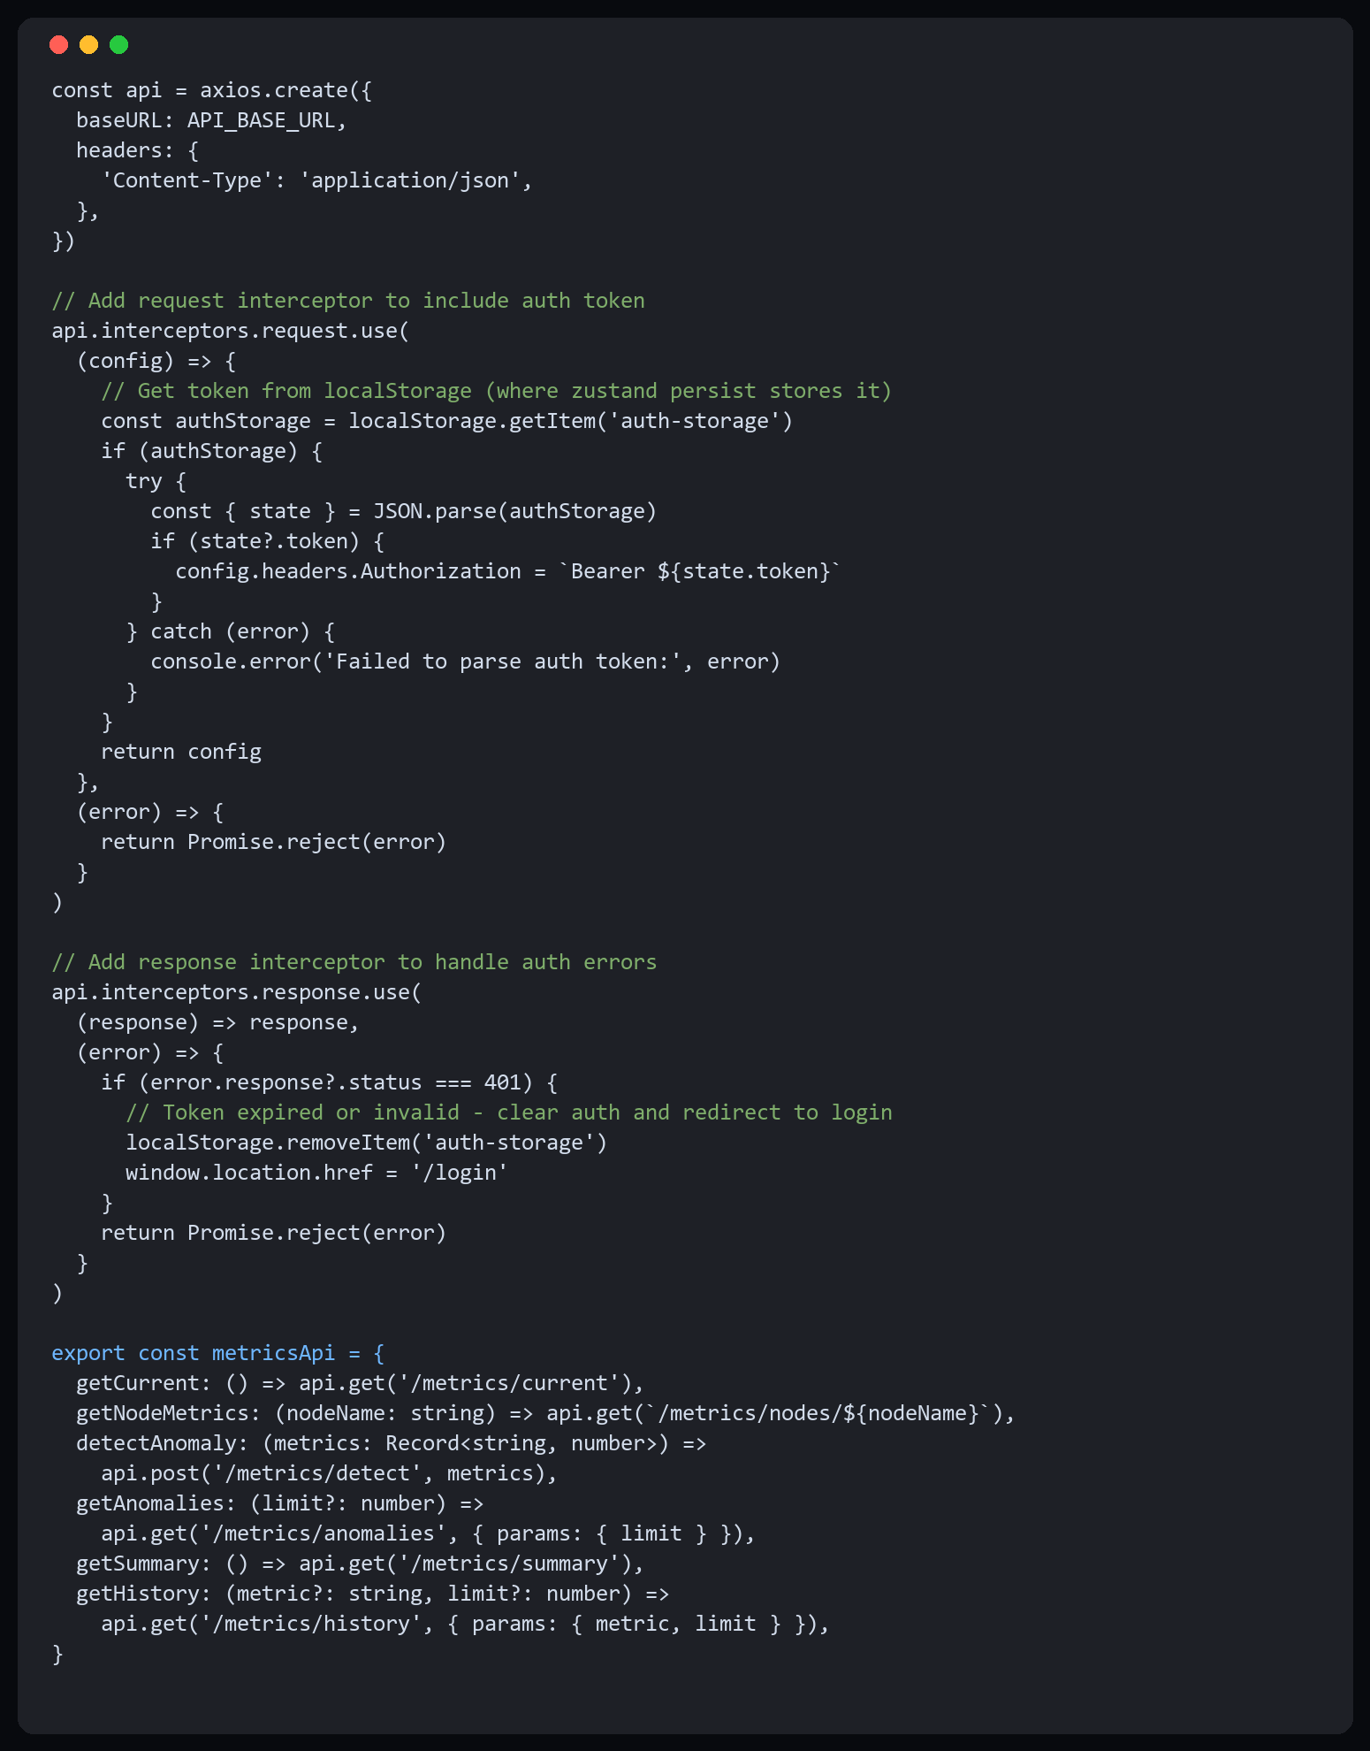
Figure 4.5. Frontend API Client and Metrics Service Integration

5 Research Methodology and Testing Approach

5.1 Overall Research Strategy
The research approach in this study follows a design-science and iterative engineering methodology. At the current first-draft stage, the primary objective is to establish a clear and testable methodological framework that connects system design decisions to measurable evaluation outcomes.
The methodological process is structured into sequential phases: requirement refinement, prototype integration, controlled testing, user-oriented validation, and result interpretation. This phased approach supports traceability from research questions to final evidence.

5.2 Functional and Technical Validation Plan
Functional validation will examine whether the system meets core requirements, including secure authentication, real-time metric visualization, anomaly alert generation, and historical event tracking. Test cases will be derived from Chapter 3 requirements, with explicit pass/fail criteria.
Technical validation will evaluate reliability under practical constraints such as API response delays, temporary node failure, and resource pressure scenarios. The goal is to verify that the dashboard remains operationally useful under partial degradation conditions.

5.3 Evaluation Metrics and Data Collection
The final evaluation will combine quality, responsiveness, and robustness indicators. Planned quantitative metrics include anomaly detection precision, recall, and F1-score, along with alert latency, dashboard refresh time, and successful request ratio under stress workloads.
Data collection will be based on backend logs, exported cluster telemetry, and experiment execution records. Each experiment cycle will preserve timestamps, input conditions, and observed outputs to support reproducibility and transparent supervisor review.

5.4 User-Oriented Validation and Validity Considerations
In addition to technical testing, user-oriented validation will involve student developers and beginner operators completing representative monitoring tasks. Feedback forms will assess usability, alert clarity, and troubleshooting efficiency to determine whether the system improves practical learning outcomes.
Potential threats to validity include limited fault diversity in controlled tests and the use of a medium-scale academic cluster rather than large production infrastructure. To mitigate these risks, multiple failure patterns will be tested and all environment assumptions will be documented in the final version.

5.5 Planned Execution Timeline (March-May 2026)
The execution timeline is organized as follows: March for full feature integration and test-script preparation, April for repeated experiment runs and data consolidation, and early May for interpretation, discussion writing, and final revision. This schedule ensures that final claims are supported by both implementation evidence and structured analysis.
The planned testing workflow and evaluation sequence are shown in Figure 5.1.
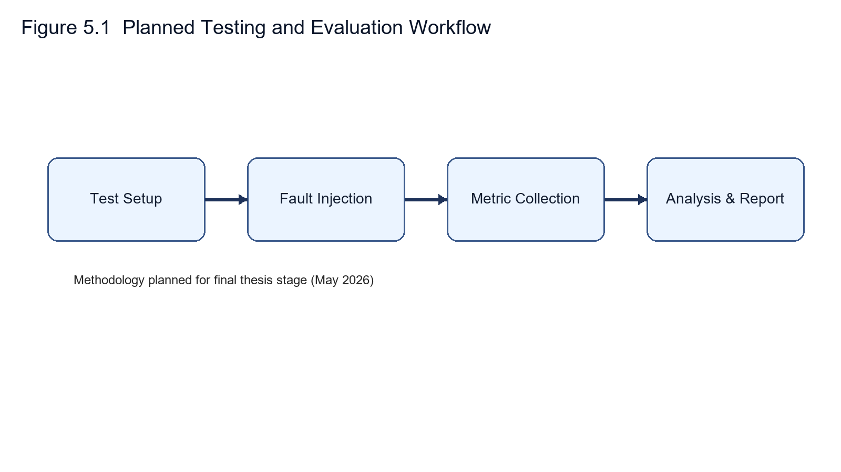

6 Conclusion

6.1 Summary of Contributions
This thesis presents the design and development of a Kubernetes monitoring dashboard with anomaly detection. As of February 2026, the project is in implementation phase. Work completed so far includes architecture design, technology stack selection, and initial component development. The system architecture, anomaly detection approach using Isolation Forest, and basic monitoring framework have been designed. Full implementation, comprehensive testing, and evaluation are planned for completion by the May 2026 final deadline.
The current draft contributes an initial implementation direction: (1) adoption of Isolation Forest for unsupervised anomaly analysis, (2) a preliminary root-cause correlation workflow across metrics, logs, and events, (3) a real-time dashboard communication design based on WebSocket updates, and (4) foundational authentication and role controls to be hardened in future iterations. Final performance claims and scalability limits are reserved for later validated experiments.

6.2 Limitations
Several limitations merit acknowledgment. The current implementation uses a single machine learning algorithm; comparative evaluation of alternative approaches could identify better-performing methods for specific use cases. Historical data retention is limited to 7 days due to storage constraints; longer retention would enable more sophisticated trend analysis and seasonal pattern detection.
Scalability testing was constrained to clusters with up to 500 containers. Larger deployments may require architectural modifications including distributed processing and time-series database adoption. Root cause analysis relies on predefined heuristics rather than learned causal models, potentially missing complex failure modes not captured in the rule base.

6.3 Future Work
Several promising directions exist for future development. Multi-cluster support would enable centralized monitoring across development, testing, and production environments from a single dashboard. Predictive analytics using time-series forecasting could anticipate resource exhaustion before it occurs, enabling proactive capacity management.
Advanced machine learning techniques including deep learning for time-series analysis and reinforcement learning for optimization could enhance both detection accuracy and diagnostic capabilities. Building a knowledge base that learns from historical incidents would improve root cause analysis over time, similar to expert systems that accumulate domain knowledge.

References
[1] Burns, B., Grant, B., Oppenheimer, D., Brewer, E., & Wilkes, J. (2016). Borg, Omega, and Kubernetes. ACM Queue, 14(1), 70-93.
[2] Sharma, P., Chaufournier, L., Shenoy, P., & Tay, Y. C. (2016). Containers and virtual machines at scale: A comparative study. Proceedings of the 17th International Middleware Conference, 1-13.
[3] Jaramillo, D., Nguyen, D. V., & Smart, R. (2016). Leveraging microservices architecture by using Docker technology. 2016 IEEE SoutheastCon, 1-5.
[4] Artac, M., Borovssak, T., Di Nitto, E., Guerriero, M., & Tamburri, D. A. (2017). DevOps: Introducing infrastructure-as-code. 2017 IEEE/ACM 39th International Conference on Software Engineering Companion (ICSE-C), 497-498.
[5] Nedelkoski, S., Cardoso, J., & Kao, O. (2021). Anomaly detection and classification using distributed tracing and deep learning. Future Generation Computer Systems, 116, 112-121.
[6] Xu, H., Pang, G., Wang, Y., & Wang, Y. (2023). Deep isolation forest for anomaly detection. IEEE Transactions on Knowledge and Data Engineering, 35(8), 8208-8221.
[7] Villamizar, M., Garcés, O., Castro, H., Verano, M., Salamanca, L., Kasanka, R., & Merino, F. (2016). Cost comparison of running web applications in the cloud using monolithic, microservice, and serverless architectures. Journal of Cloud Computing, 5(1), 14.
[8] Dragoni, N., Giallorenzo, S., Lafuente, A. L., Mazzara, M., Montesi, F., Mustafin, R., & Safina, L. (2017). Microservices: Yesterday, today, and tomorrow. Present and Ulterior Software Engineering, 195-216.
[9] Hasselbring, W., & Steinacker, G. (2017). Microservice architecture patterns. Proceedings of the 11th European Conference on Software Architecture (ECSA), 221-228.
[10] Wang, Y., Yang, J. H., Xu, C., Ling, X., & Yang, Y. (2015). A review of cloud computing access control technology research. Journal of Software, 26(6).
[11] Wu, Z. (2017). Development and trends of cloud computing virtualization technology. Computer Applications Research, 34(4).
[12] Jiang, D., Liu, X., & Goh, C. T. (2019). A review of current status of cloud computing t echnology development. Information Technology, 2019.
[13] Li, X., Gao, X., Yan, B., Chen, C., Chen, B., Li, J., & Xu, J. (2019). An anomaly detection method for power dispatch flow data based on the isolated forest algorithm. Power System Technology, 43(4).
[14] Ramírez, T. (2020). FastAPI Framework: high performance, easy to learn, fast to code, ready for production. Python Software Foundation.
[15] Fedosejev, A. (2015). React.js Essentials. Packt Publishing Ltd.

